

FACULTY OF ENGINEERING AND TECHNOLOGY

A REPORT ABOUT VISUALIZING AND ANALYZING OF DATA

COURSE UNIT: COMPUTER PROGRAMMING

LECTURER: MR. MASERUKA BENEDICTO

GROUP 13
SUBMITTED BY
NAME | COURSE | REG. NO.
NYEMERA ANNA GRACE | AMI | BU/UP/2024/0838
NASASIRA AUSTINE | WAR | BU/UP/2024/1048
BARASA ELVIS | AMI | BU/UP/2024/3817
BRAVO GIFT | PTI | BU/UG/2024/5059
NAMUWAWU PATRICIA | APE | BU/UG/2024/2670
AINAMATSIKO JEREMIAH | WAR | BU/UP/2024/3826
ACHAM LOYCE | AMI | BU/UP/2024/0821
MUGUME MATHIAS | MEB | BU/UP/2024/0983
ABUROT MARTHA | WAR | BU/UP/2024/3823
KINTU GADAFFI | AMI | BU/UP/2024/3734

DATE OF SUBMISSION: ………………………………
DECLARATION
We hereby certify and confirm that the information in this report is out of our own efforts, research and it has never been submitted in any institution for any academic award

NAME SIGNATURE
- NASASIRA AUSTINE …………………………
- KINTU GADAFI …………………………
- ABUROT MARTHA …………………………
- MUGUME MATHIAS ………………………….
- ACHAM LOYCE ………………………….
- AINAMATSIKO JEREMIAH ………………………….
- NAMUWAWU PATRICIA …………………………..
- BRAVO GIFT …………………………..
- NYEMERA ANNA GRACE …………………………..
- BARASA ELVIS …………………………..

APPROVAL
We are presenting this report which has been written and produced under our efforts. We carried out research on visualizing the different parameters, patterns, trends and relationships of data.

ACKNOWLEDGEMENT
First and foremost, we would like to thank the Almighty God for giving us the strength to carry on with our research as Group 13. We would love to extend our gratitude to all the persons with whose help we managed to make it this far

The willingness of each one of us to invest time and provide constructive feedback has been immensely valuable in this assignment.
Finally, we would like to express our gratitude to all the sources and references that have been cited in this report

DEDICATION.
We dedicate this report to all the individuals especially Group 13 members, who have been there for us in the process of formulating and producing this report. To our lecturer Mr. Maseruka Benedicto whose guidance and expertise have been invaluable, your mentorship and insightful feedback have shaped our understanding.

ABSTRACT
We started our research from 18th September, 2025 in the university library with division of work for intense research in the different sections, where were obtained the best ways of how to do the assignment and that are used in the engineering field to solve problems. Information we used was mainly obtained from YouTube tutorials. Plotting the time, accuracy graphs and the number of steps followed graph. The division of work, eased the work and saved time.

Table of Contents
1 CHAPTER ONE: INTRODUCTION 9
1.1 Background. 9
1.2 Historical Development 9
Early Development (1970s) 9
Commercialization and Expansion (1980s) 10
Continued Evolution (1990s to Present) 10
1 CHAPTER 2: STUDY METHODOLOGY 11
2:1 Introduction 11
2.2 Discussion chapter 12
MATLAB Tools and Environment 12
Code Quality and Maintainability 12
3 CHAPTER THREE: TASK ONE 14
Introduction 14
Task one 14
READING THE DATA INTO MATLAB 14
CREATING TABLES OF DIFFERENT YEARS 14
CONVERTING THE TABLES INTO STRUCTURAL ARRAYS INTO DIFFERENT WORKSHEETS 15
EXPORTING THE DATA TO EXCEL 16
ANALYZED DATA THROUGH STATISTICS 17
VISUALIZING OF THE DATA 19
2 CHAPTER FOUR: TASK TWO 21
Introduction 21
Task two 21
CODES OF THE ACTIVIES DONE 21
CHAPTER 8: CONCLUSION AND RECOMMENDATION 27
8.1 Recommendations 27
1. Understand Your Data and Purpose: 27
Clearly identify the specific questions you aim to answer with your data analysis. 27
Understand the data types, distributions, and potential relationships within your dataset before visualizing. 27
2. Choose the Right Visualization Type: 27
Select plot types that effectively represent your data and the insights you want to convey (e.g., plot for time series, scatter for relationships, histogram for distributions, surf for 3D surfaces). 27
3. Enhance Clarity and Impact: 27
• Simplify: 27
• Use Labels and Titles: 27
• Color and Styling: 27
Use color, line styles, markers, and sizes strategically to highlight key data points or differentiate categories. 27
4. Programmatic Control for Reproducibility and Customization: 27
Use built-in plotting functions and customize their properties programmatically for fine-grained control over appearance. 27
5. Best Practices for Data Handling: 27
Clean, filter, and transform your data appropriately before visualization to ensure accuracy and meaningful insights. 27
8.2 Conclusion 28

CHAPTER ONE: INTRODUCTION

Background.
MATLAB, which stands for matrix laboratory, is a high-performance programming language and environment designed primarily for technical computing. Its origins trace back to the late 1970s when Cleve Moler, a professor of computer science, developed it to provide his students with easy access to mathematical software libraries without requiring them to learn Fortran.

1.2 Historical Development

Early Development (1970s)
- Origins in Matrix Algebra: MATLAB's foundation was built on research papers by J. H. Wilkinson and others, focusing on algorithms for solving matrix linear equation and eigenvalue problems.
- Academic Tool: Cleve Moler, a mathematics professor, developed the initial Fortran-based version in the 1970s as a free, interactive tool for his students, called the "Matrix Laboratory".
- Basis in LINPACK and EISPACK: This early version used subroutines from the LINPACK and EISPACK matrix software libraries for solving linear equations and eigenvalue problems.

Commercialization and Expansion (1980s)
- Commercial Launch: In 1984, Cleve Moler and John N. Little commercialized the software, founding MathWorks to market it to engineers and scientists.
- Rewritten in C: The commercial version was a significant rewrite of the original Fortran code, incorporating a proper programming language, user functions, and graphics capabilities.
- Toolboxes: Early toolboxes were introduced, including the Control System Toolbox (1985) and the Signal Processing Toolbox (1987), significantly expanding MATLAB's capabilities.

Continued Evolution (1990s to Present)
- Advanced Data Structures: The introduction of sparse matrices in 1992 and toolboxes like Image Processing and Symbolic Math in 1993 marked further advancements.
- Broadened Scope: While initially focused on numerical linear algebra, MATLAB evolved into a comprehensive technical computing environment for a wide range of applications.
- Modern Capabilities: Today, MATLAB supports advanced features such as parallel computing, object-oriented programming, and extensive integration with other languages and platform. It has also introduced features like the Live Editor, which allows users to create interactive documents that combine code, output, and formatted text. This evolution reflects MATLAB's ongoing adaptation to meet the needs of its diverse user base across academia and industry.

CHAPTER 2: STUDY METHODOLOGY

2:1 Introduction
At the start time of the research, we divided ourselves accordingly to enable easy understanding of work and great participation of members in the assignment. Both groups organized discussions and discussed their findings to the entire group after thorough research.
Names and question researched

NAME | QUESTION RESEACHED
NASASIRA AUSTINE  KINTU GADAFI  ABUROT MARTHA  MUGUME MATHIAS  ACHAM LOYCE | Question Two
AINAMATSIKO JEREMIAH  NAMUWAWU PATRICIA  BRAVO GIFT  NYEMERA ANNA GRACE  BARASA ELVIS | Question One

2.2 Discussion chapter

MATLAB Tools and Environment
All members were encouraged to know how to use the MATLAB Tools and study its environment to be well conversant with it. Some of the keynotes members were advised to observe are as follows
- Become familiar with the MATLAB desktop environment, including the Current Folder, Command Window, and Workspace.
- Use the MATLAB documentation, such as the MathWorks website, to find information on best practices, specific functions, and troubleshooting.
- Explore and use the various apps available in MATLAB for different tasks, depending on your installed toolboxes.

Code Quality and Maintainability
When generating the code the members came to a conclusion to follow certain guidelines as mentioned below;
- Focus on producing code that is more likely to be correct.
- Make your code readable to others and yourself by using meaningful variable names and consistent formatting.
- Provide comments and explanations within your code to help with future maintenance and understanding.
- Incorporate testing into your development process to ensure code functionality and reliability.

3 CHAPTER THREE: TASK ONE

Introduction
Task one was about using the knowledge obtained in question one in the first assignment to visualize the different parameters, patterns, trends and relationships.

Task one
In this task, we were able to obtain a file from Kaggle.com named “Electric cars dataset” and using this data, we were able to do the following activities
- Reading the data into MATLAB
- Creating tables of different years
- Converting the tables into structural arrays into different worksheets
- Exporting the data to excel
- Analyzed data through statistics
- Visualizing of the data

READING THE DATA INTO MATLAB
The code that was used is as follows
data = readtable("C:\Users\LENOVO\Desktop\Electric cars dataset.xlsx");
disp(data);

CREATING TABLES OF DIFFERENT YEARS
Year2015 = data(data.Year == 2015, :);
Year2016 = data(data.Year == 2016, :);
Year2017 = data(data.Year == 2017, :);
Year2018 = data(data.Year == 2018, :);
Year2019 = data(data.Year == 2019, :);
Year2020 = data(data.Year == 2020, :);
Year2021 = data(data.Year == 2021, :);
Year2022 = data(data.Year == 2022, :);
Year2023 = data(data.Year == 2023, :);
Year2024 = data(data.Year == 2024, :);
Year2025 = data(data.Year == 2025, :);
disp(Year2015);
disp(Year2016);
disp(Year2017);
disp(Year2018);
disp(Year2019);
disp(Year2020);
disp(Year2021);
disp(Year2022);
disp(Year2023);
disp(Year2024);
disp(Year2025);

CONVERTING THE TABLES INTO STRUCTURAL ARRAYS INTO DIFFERENT WORKSHEETS
struct2015 = table2struct(Year2015);
struct2016 = table2struct(Year2016);
struct2017 = table2struct(Year2017);
struct2018 = table2struct(Year2018);
struct2019 = table2struct(Year2019);
struct2020 = table2struct(Year2020);
struct2021 = table2struct(Year2021);
struct2022 = table2struct(Year2022);
struct2023 = table2struct(Year2023);
struct2024 = table2struct(Year2024);
struct2025 = table2struct(Year2025);
disp(struct2015);
disp(struct2016);
disp(struct2017);
disp(struct2018);
disp(struct2019);
disp(struct2020);
disp(struct2021);
disp(struct2022);
disp(struct2023);
disp(struct2024);
disp(struct2025);

EXPORTING THE DATA TO EXCEL

output1 = "C:\Users\LENOVO\Desktop\Question1\car_struct2015.xlsx"
writetable(Year2015,output1,"Sheet","Year2015");

output2 = "C:\Users\LENOVO\Desktop\Question1\car_struct2016.xlsx"
writetable(Year2016,output2,"Sheet","Year2016");

output3 = "C:\Users\LENOVO\Desktop\Question1\car_struct2017.xlsx"
writetable(Year2017,output3,"Sheet","Year2017");

output4 = "C:\Users\LENOVO\Desktop\Question1\car_struct2018.xlsx"
writetable(Year2018,output4,"Sheet","Year2018");

output5 = "C:\Users\LENOVO\Desktop\Question1car_struct2019.xlsx"
writetable(Year2019,output5,"Sheet","Year2019");

output6 = "C:\Users\LENOVO\Desktop\Question1\car_struct2020.xlsx"
writetable(Year2020,output6,"Sheet","Year2020");

output7 = "C:\Users\LENOVO\Desktop\Question1\car_struct2021.xlsx"
writetable(Year2021,output7,"Sheet","Year2021");

output8 = "C:\Users\LENOVO\Desktop\Question1\car_struct2022.xlsx"
writetable(Year2022,output8,"Sheet","Year2022");

output9 = "C:\Users\LENOVO\Desktop\Question1\car_struct2023.xlsx"
writetable(Year2023,output9,"Sheet","Year2023");

output10 = "C:\Users\LENOVO\Desktop\Question1\car_struct2024.xlsx"
writetable(Year2024,output10,"Sheet","Year2024");

output11 = "C:\Users\LENOVO\Desktop\Question1\car_struct2025.xlsx"
writetable(Year2025,output11,"Sheet","Year2025");

ANALYZED DATA THROUGH STATISTICS

Yearly_distribution_of_cars = groupsummary(data,"Year")
disp(Yearly_distribution(:,["Year","GroupCount"]));

Country_distribution_of_cars = groupsummary(data,"Country_of_Manufacture")
disp(Country_distribution_of_cars(:,["Country_of_Manufacture","GroupCount"]));
maximum_Country_distribution_of_cars = max(Country_distribution_of_cars.GroupCount);
disp(maximum_Country_distribution_of_cars);
fprintf("mean country distribution of cars: %.2f\n",mean(Country_distribution_of_cars.GroupCount));
fprintf("mode country distribution of cars: %.2f\n",mode(Country_distribution_of_cars.GroupCount));
fprintf("median country distribution of cars: %.2f\n",median(Country_distribution_of_cars.GroupCount));
fprintf("standard deviation country distribution of cars: %.2f\n",std(Country_distribution_of_cars.GroupCount));
fprintf("maximum country distribution of cars: %.d\n",max(Country_distribution_of_cars.GroupCount));
fprintf("minimum country distribution of cars: %.d\n",min(Country_distribution_of_cars.GroupCount));

Color_distribution_of_cars = groupsummary(data,"Color")
disp(Color_distribution_of_cars(:,["Color","GroupCount"]));

Manufacturer_distribution_of_cars = groupsummary(data,"Manufacturer")
disp(Manufacturer_distribution_of_cars(:,["Manufacturer","GroupCount"]));
fprintf("mean Manufacturer distribution of cars: %.2f\n",mean(Manufacturer_distribution_of_cars.GroupCount));
fprintf("mode Manufacturer distribution of cars: %.2f\n",mode(Manufacturer_distribution_of_cars.GroupCount));
fprintf("median Manufacturer distribution of cars: %.2f\n",median(Manufacturer_distribution_of_cars.GroupCount));
fprintf("standard deviation Manufacturer distribution of cars: %.2f\n",std(Manufacturer_distribution_of_cars.GroupCount));
fprintf("maximum Manufacturer distribution of cars: %.d\n",max(Manufacturer_distribution_of_cars.GroupCount));
fprintf("minimum Manufacturer distribution of cars: %.d\n",min(Manufacturer_distribution_of_cars.GroupCount));

Model_distribution_of_cars = groupsummary(data,"Model")
disp(Model_distribution_of_cars(:,["Model","GroupCount"]));

Battery_Type_distribution_of_cars = groupsummary(data,"Battery_Type")
disp(Battery_Type_distribution_of_cars(:,["Battery_Type","GroupCount"]));
fprintf("mean Battery Type distribution of cars: %.2f\n",mean(Battery_Type_distribution_of_cars.GroupCount));
fprintf("mode Battery Type distribution of cars: %.2f\n",mode(Battery_Type_distribution_of_cars.GroupCount));
fprintf("median Battery Type distribution of cars: %.2f\n",median(Battery_Type_distribution_of_cars.GroupCount));
fprintf("standard deviation Battery Type distribution of cars: %.2f\n",std(Battery_Type_distribution_of_cars.GroupCount));
fprintf("maximum Battery Type distribution of cars: %.d\n",max(Battery_Type_distribution_of_cars.GroupCount));
fprintf("minimum Battery Type distribution of cars: %.d\n",min(Battery_Type_distribution_of_cars.GroupCount));

VISUALIZING OF THE DATA

bar(Yearly_distribution_of_cars.Year,Yearly_distribution_of_cars.GroupCount);
xlabel("YEARS");
ylabel("NUMBER OF CARS");
title("DISTRIBUTION OF CARS PER YEAR");
saveas(gcf,"bar graph.png");
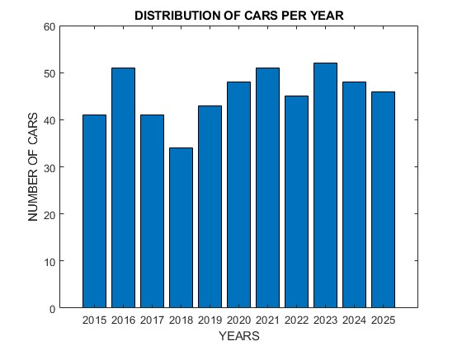

barh(Country_distribution_of_cars.Country_of_Manufacture,Country_distribution_of_cars.GroupCount);
xlabel("country of manufacture");
ylabel("Number of cars");
title("A bar graph showing distribution of cars between the manufacturing countries")
saveas(gcf,"horizontal bar.png");
grid on;
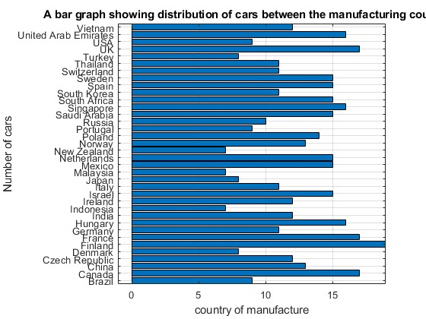

pie(Yearly_distribution_of_cars.GroupCount,Yearly_distribution_of_cars.Year);
title("distribuction of cars per year");
legend("2015","2016","2017","2018","2019","2020","2021","2022","2023","2024","2025");
saveas(gcf,"pie chart.png");
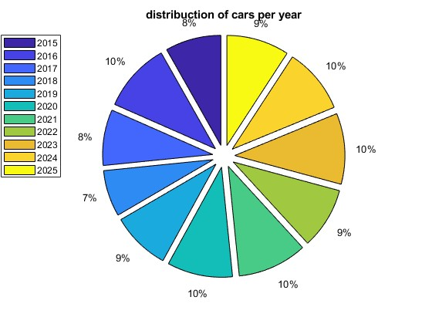

pareto(Yearly_distribution_of_cars.GroupCount);
title("distribuction of cars per year");
xlabel("YEARS");
ylabel("NUMBER OF CARS");
saveas(gcf,"pareto.png");
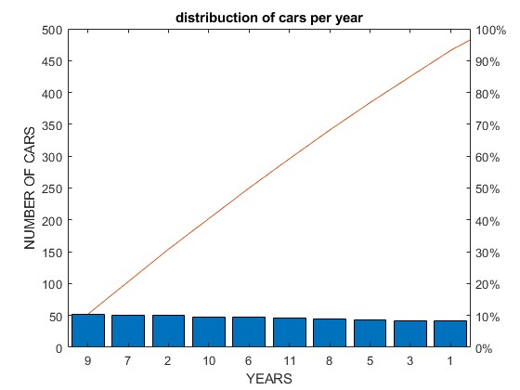

boxplot(Yearly_distribution_of_cars.GroupCount);
title("A Boxplot showing distribution of cars between the manufacturing countries")
saveas(gcf,"boxplot.png");
grid on;
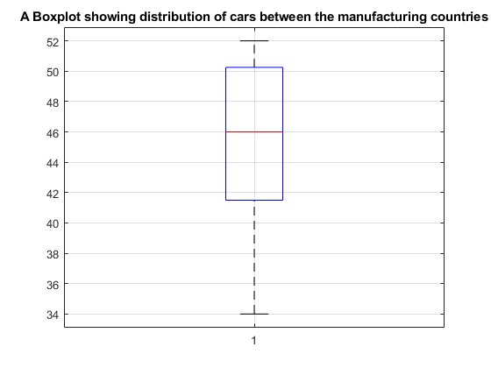

histogram(Yearly_distribution_of_cars.GroupCount);
xlabel("YEARS");
ylabel("NUMBER OF CARS");
title("A Histogram showing distribution of cars between the manufacturing countries")
saveas(gcf,"histogram.png");
grid on;
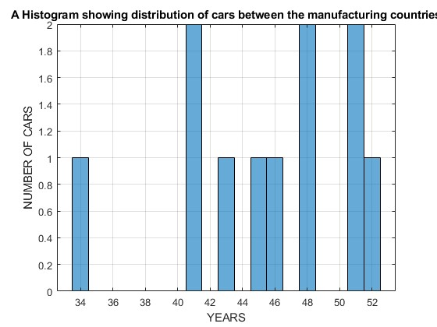

x = data.Charge_Time_hr;
y = data.Battery_Capacity_kWh;
z = data.CO2_Emissions_g_per_km;
fill3(x,y,z,'r')
title("fill3 showing charge time,battery capacity and emission of carbondioxide");
xlabel("charge time");
ylabel("battery capacity");
zlabel("carbon emission")
saveas(gcf,"fill3.png");
grid on;
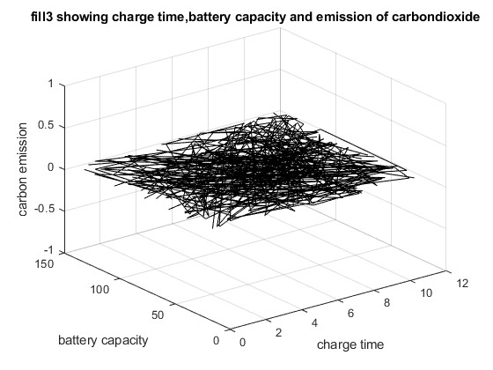

scatter(data.Battery_Capacity_kWh,data.Price_USD,".r");
xlabel("Battery capacity");
ylabel("Price");
title("scatter plot for relationship between Battery capacity and price");
saveas(gcf,"scatter1.png");
grid on;
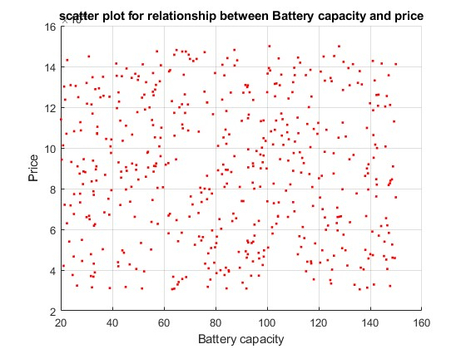
scatter(data.Units_Sold_2024,data.Price_USD,"*g");
xlabel("units sold in 2024")
ylabel("Price_USD")
title("scattter graph showing relationship between price and units sold in 2024");
grid on;
saveas(gcf,"scatter2.png");
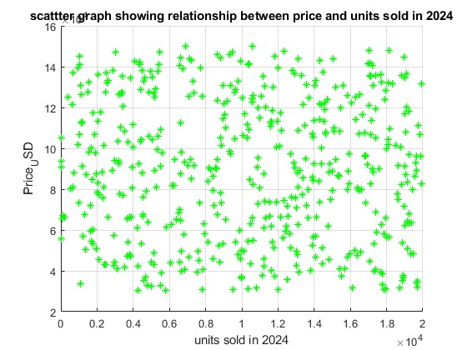

CHAPTER FOUR: TASK TWO

Introduction
Task Two was about describing the different statistical characteristic of data and visualizing it. The data was collected from the group members with their different attributes detailed enough to describe them

Task two
In task two, after collecting the necessary information from all the members, we then obtained codes for the following activities;
- Created a table for the data collected
- Obtained statistical analysis on religion, tribes, hobbies and districts
- Obtained statistics (mode, mean, standard deviation, maximum and minimum values)
- Visualizing of the data

CODES OF THE ACTIVIES DONE
Created a table for the data collected
Name = ["Bravo Gift";"Austine NASASIRA";"Patricia Namuwawu";"Nyemere Anna Grace";"Kintu Gadaffi";"Jeremiah Ainamatsiko";"Mugume Mathias";"Aburot Martha";"Earasa Elvis";"Acham Royce"];
Age = [21;22;21;22;22;21;22;26;23;22;];
Tribe = ["alur";"munyankole";"muganda";"itesot";"muganda";"munyankole";"munyankole";"itesot";"samia";"langi"];
District = ["pakwach";"bushenyi";"masaka";"butebo";"mityana";"kazo";"bushenyi";"amuria";"busia";"lira"];
Hobby = ["music";'dancing';"reading";"footbal";"swimming";"music";"praying";"adventure";"football";"adventure"];
YearofBirth = [2004;2003;2004;2003;2003;2004;2003;1999;2002;2003];
IncomeLevel = [23;34;68;90;23;12;6;23;45;89];
WeeksAttended = [8;9;10;11;12;13;10;11;14;15];
MarksScored = [51;56;79;90;89;67;56;54;53;60];
Course = ["PTI";"WAR";"APE";"AMI";"AMI";"WAR";"MEB";"WAR";"AMI";"AMI"];
Religion = ["catholic";"catholic";"anglican";"catholic";"muslim";"anglican";"catholic";"anglican";"anglican";"catholic"];

Students = table(Name,Age,Tribe,District,Hobby,YearofBirth,IncomeLevel,WeeksAttended,MarksScored,Course,Religion);
disp(Students);
Obtained statistical analysis on religion, tribes, hobbies and districts
distribution of religion

Religion_distribution = groupsummary(Students,"Religion");
disp(Religion_distribution(:,["Religion","GroupCount"]));

distribution of tribes

Tribe_distribution = groupsummary(Students,"Tribe");
disp(Tribe_distribution(:,["Tribe","GroupCount"]));

distribution of hobbies

HObby_distribution = groupsummary(Students,"Hobby");
disp(HObby_distribution(:,["Hobby","GroupCount"]));

distribution of districts

District_distribution = groupsummary(Students,"District");
disp(District_distribution(:,["District","GroupCount"]));

- Obtained statistics (mode, mean, standard deviation, maximum and minimum values)
- fprintf("mean Age: %.2f\n",mean(Students.Age));
- fprintf("median Age: %.2f/n",median(Students.Age));
- fprintf("modal Age: %.2f/n",mode(Students.Age));
- fprintf("standard dviation Age: %.2f/n",std(Students.Age));
- fprintf("minimum Age: %d/n",min(Students.Age));
- fprintf("maximum Age: %d/n",max(Students.Age))

- statistics on marks
- fprintf("mean mark scored: %.2f\n",mean(Students.MarksScored));
- fprintf("median mark scored: %.2f\n",median(Students.MarksScored));
- fprintf("modal mark scored: %.2f\n",mode(Students.MarksScored));
- fprintf("standard deviation mark scored: %.2f\n",mean(Students.MarksScored));
- fprintf("maximum mark scored: %.d\n",max(Students.MarksScored));
- fprintf("minimum mark scored: %.d\n",min(Students.MarksScored));

- statistic on income level

- fprintf("mean income level: %.2f\n",mean(Students.IncomeLevel));
- fprintf("median income level: %.2f\n",median(Students.IncomeLevel));
- fprintf("modal income level: %.2f\n",mode(Students.IncomeLevel));
- fprintf("standard deviation income level: %.2f\n",std(Students.IncomeLevel));
- fprintf("maximum income level: %.d\n",max(Students.IncomeLevel));
- fprintf("minimum income level: %.d\n",min(Students.IncomeLevel));

Visualizing of the data
relationship between students' age and year of birth

plot(Age,YearofBirth,"g");
xlabel("student age");
ylabel("Year of birth");
title("Relationship between age and year of birth");
grid on;
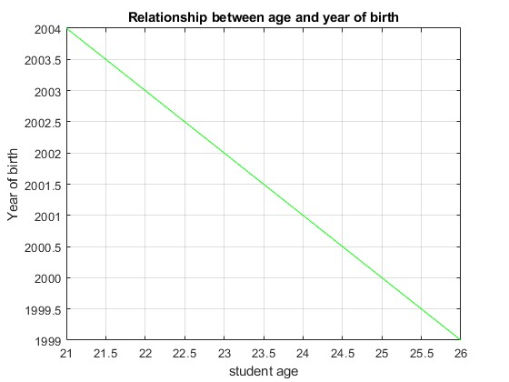

relationship between income level and marksscored

plot(IncomeLevel,MarksScored,"b*");
xlabel("student income level");
ylabel("mark scored by student");
title("relation between student income level and mark scored by student");
grid on;
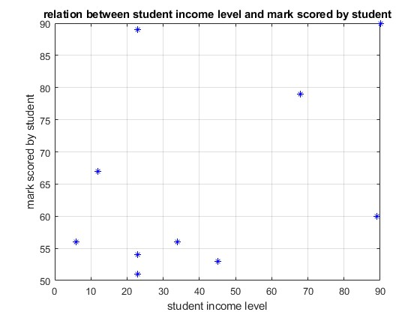

relationship of markscored and weeks attended

scatter(MarksScored,WeeksAttended,"r");
xlabel("marks scored");
ylabel("weeks Attended");
title("scatter plot showing relatoinship between weeks attended and marks scored");
grid on;
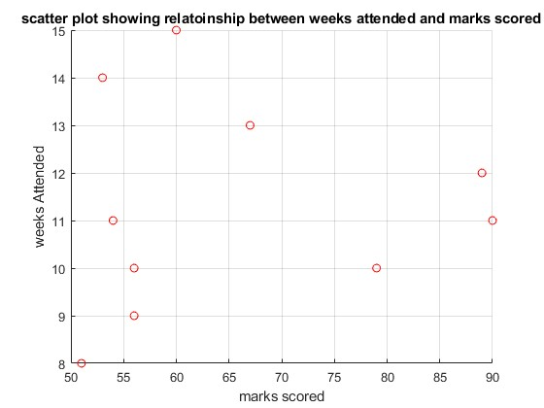
relationship of age and marks scored

scatter(Age,MarksScored,"magenta");
xlabel("age");
ylabel("mark scored");
title("scatter plot showing age of student against their markes");
grid on;
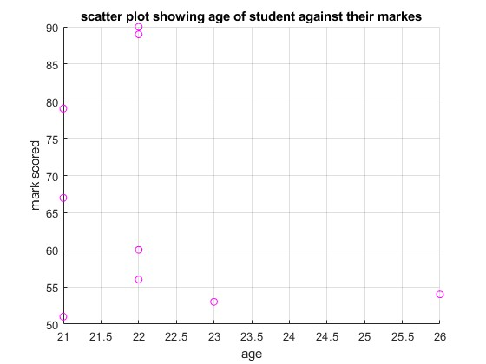

Bar Graph
x = categorical(Name)
y = MarksScored
bar(x,y,"g");
title("A bar graph showing students and their marks");
ylabel("Marks Scored");
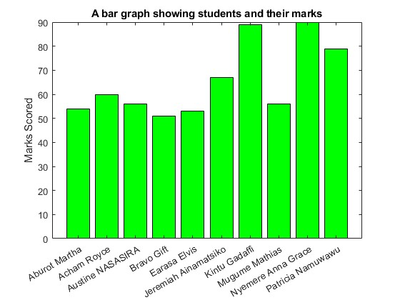

CHAPTER 8: CONCLUSION AND RECOMMENDATION

8.1 Recommendations

1. Understand Your Data and Purpose:

Clearly identify the specific questions you aim to answer with your data analysis.

Understand the data types, distributions, and potential relationships within your dataset before visualizing.

2. Choose the Right Visualization Type:

Select plot types that effectively represent your data and the insights you want to convey (e.g., plot for time series, scatter for relationships, histogram for distributions, surf for 3D surfaces).

3. Enhance Clarity and Impact:

Simplify:

Use Labels and Titles:

Color and Styling:

Use color, line styles, markers, and sizes strategically to highlight key data points or differentiate categories.

4. Programmatic Control for Reproducibility and Customization:

Use built-in plotting functions and customize their properties programmatically for fine-grained control over appearance.

5. Best Practices for Data Handling:

Clean, filter, and transform your data appropriately before visualization to ensure accuracy and meaningful insights.

8.2 Conclusion
The analysis and visualization of data using MATLAB successfully revealed clear commuting patterns that were not obvious from the raw dataset.
Overall, MATLAB's data visualization tools proved highly effective for transforming a complex dataset into meaningful and actionable insights for urban planning and traffic management.

References
Books
- Fundamentals of Data Science with MATLAB: Introduction to Scientific Computing, Data Analysis, and Data Visualization by Arash Karimpour.
- MATLAB: Data Analysis and Visualization by Antonio Siciliano.

